Supplementary Material
Supplementary methods
ARIC
The ARIC study is a prospective population-based study of atherosclerosis and cardiovascular disease that included 15792 participants (27% African American) aged 45-64 years at baseline visit (1987-89, visit 1) from four US communities¹. Participants completed follow-up visits in 1990-92 (visit 2), 1993-95 (visit 3), 1996-98 (visit 4), and 2011-13 (visit 5). In this study, 955 T2D subjects diagnosed at any of the first four visits (visits 1-4) and 414 subjects with normal glucose tolerance (NGT) at visits 1-4 were included. All subjects were self-reported African American recruited from two communities (Jackson, MS and Forsyth, NC).
CARDIA
The CARDIA study is a prospective multi-center investigation of the natural history and etiology of cardiovascular disease that included 5115 participants (52% African American) aged 18-30 years at baseline visit from four US communities (Birmingham, AL; Chicago, IL; Minneapolis, MN and Oakland, CA)². Follow-up examinations occurred at years 2, 5, 7, 10, 15 and 20. In this study, 94 T2D subjects diagnosed at any visits and 654 subjects with NGT in all visits were included. All subjects were self-reported African American.
JHS
JHS is a prospective population-based study to examine the risk factors of cardiovascular diseases among 5301 African American from two cohorts of unrelated (aged 35-84 years) and nested family-based (aged ≥21 years) subjects in the Jackson, Mississippi metropolitan area³. The mean family size was 1.4±1.5 subjects per family. In this study, 333 T2D and 1450 NGT subjects at baseline visit who were not enrolled in the ARIC study were included. The respective mean family size was 1.3±1.4 subjects per family, and 88% of families are singletons. Family relationship was not accounted during association analysis due to the low degree of relatedness.
MESA
MESA is a prospective community-based study of the characteristics of subclinical cardiovascular disease and included 6,814 individuals (28% African American) free from known cardiovascular disease between 45–84 years old at baseline⁴. Subjects were recruited from six field centers (Wake Forest School of Medicine, Columbia University, Johns Hopkins University, University of Minnesota, Northwestern University and University of California - Los Angeles). Data from up to the fifth visit are available for analyses (Exam 1 2000-02, Exam 2 2002-04, Exam 3 2004-05, Exam 4 2005-07, Exam 5 2010-12). In this study, 411 T2D subjects diagnosed in any visit up to Exam 4 and 793 subjects with NGT in all visits up to Exam 4 who were self-reported African American were included.

WFSM
The WFSM study is a cross-sectional case-control study designed to examine the genetics of T2D and end-stage renal disease (ESRD) in African American^{5,6}. In this study, the cases included 932 subjects with both T2D and ESRD recruited from dialysis facilities. In addition, cases had at least one of the following inclusion criteria: a) T2D diagnosed at least 5 years before initiating renal replacement therapy, b) background or greater diabetic retinopathy and/or c) ≥100 mg/dl proteinuria on urinalysis in the absence of other causes of nephropathy. The controls included 856 African American subjects without a current diagnosis of diabetes or renal disease recruited from the community and internal medicine clinics. All subjects were recruited in North Carolina, South Carolina, Georgia, Tennessee or Virginia.

Running GxG interaction in PLINK:
  - PLINK flags (in order)
    - --bfile: calls binary (bed/bim/fam) genotype/phenotype files
    - --pheno: calls alternate phenotype file
    - --logistic: specifies additive logit link regression model
    - --covar: calls covariate file
    - --interaction: adds all SNPxCovariate interaction variables to the analytical space
    - --parameters: specifies which covariate and SNPxCovariate interaction variables to include in the model (refer to the PLINK user manual for more information on this command)
    - --out: specifies name of output file
  - Model: $Y=β_{0}+β_{1}ADD+β_{2}Sex+β_{3}Age+β_{4}PC1+β_{5}SNP+β_{9}ADD×SNP$
    - Beta 1 refers to the effect of the additive coded (0, 1, or 2) SNP in your genotype file
    - Betas 2, 3, and 4 are covariate effects
    - Beta 5 is the marginal effect of the “interacting” variable (i.e. the additive coded SNP or genetic risk score in this study)
    - Beta 9 is the effect of the interaction term
  - Null Hypothesis:
    - $H_{0}: β_{9}=0$ (i.e. PLINK will conduct the 1 degree-of-freedom test for the interaction effect in the model)
  - Example PLINK command line:
plink --bfile myfile --pheno pheno.txt --logistic --covar covar.txt --interaction --parameters 1,2,3,4,5,9 --out outfile

Supplementary data
Supplementary Table 1. Descriptive characteristics of IRASFS African Americans

Characteristic* | Value
N | 492
Pedigrees | 42
Mean pedigree size | 11.7
Male (%) | 42.4
Age (years) | 41.2±13.7
Acute Insulin Response (µU ml⁻¹ min) | 1002.2±820.9
Insulin Sensitivity (x10⁻⁴ min⁻¹ µU⁻¹ ml) | 1.6±1.2
Disposition Index | 1425.5±1273.7
BMI (kg/m²) | 29.1±5.1
African ancestry proportion | 0.75±0.12

*Data are shown as count, mean, percentage, or mean ± SD or percentage

Supplementary Table 2. Descriptive characteristics of African American diabetes case and control subjects

Characteristic | ARIC |  | CARDIA |  | JHS |  | MESA |  | WFSM
 | case | control | case | control | case | control | case | control | case | control
N | 955 | 414 | 94 | 654 | 333 | 1450 | 411 | 793 | 932 | 856
Male (%) | 35.8 | 31.2 | 19.2 | 38.2 | 33.9 | 38.7 | 47.2 | 42.4 | 38.8 | 43.7
Age (years)* | 61.3±6.0 | 59.6±6.3 | 40.5±3.8 | 38.2±4.4 | 55.5±10.7 | 48.6±11.3 | 67.6±9.2 | 65.3±10.5 | 61.6 ±10.5 | 49.0±11.9
Age at diagnosis of T2D (years) | 50.9±9.2 | - | 35.0±5.5 | - | 46.2±11.0 | - | 54.6±10.9 | - | 41.6±12.3 | -
BMI (kg/m2)* | 32.0±6.7 | 27.6±5.7 | 33.8±8.1 | 29.6±6.8 | 35.2±7.5 | 31.4±7.5 | 31.7±6.2 | 28.6±5.8 | 29.7±7.1 | 30.0±7.1
African ancestry proportion | 0.83±0.10 | 0.83±0.09 | 0.83±0.08 | 0.80±0.11 | 0.83±0.08 | 0.82±0.09 | 0.79±0.14 | 0.78±0.14 | 0.80±0.11 | 0.78±0.11

Data are shown as count, percentage, or mean ± SD. *Age and BMI are shown for the last available visit for the prospective studies including ARIC, CARDIA, and MESA (Exam 4); and the baseline visit for JHS and WFSM

Supplementary Table 3. Association of T2D-IS GRS with AIR_{g} and DI in IRASFS

 | AIR_{g} |  | DI
 | Beta | P-value | Beta | P-value
Unweighted
Model 1* | -0.16 | 7.24E-01 | 0.56 | 3.56E-01
Model 2† | -0.15 | 7.30E-01 | 0.51 | 3.86E-01
Weighted
Model 1* | 1.77 | 5.59E-01 | 8.26 | 4.43E-02
Model 2† | 1.89 | 5.29E-01 | 8.02 | 4.51E-02

*Model 1 is adjusted for age, gender, and pc1. †Model 2 is adjusted for age, gender, pc1, and BMI

Supplementary Figure 1. Q-Q plot for meta-analyzed interactions with T2D-IS SNP rs7119 (HMG20A) regressed on T2D risk in ARIC, CARDIA, JHS, MESA, and WFSM from interaction models adjusted for age, gender, and PC1.

Supplementary Figure 2. Q-Q plot for meta-analyzed interactions with weighted T2D-IS GRS regressed on T2D risk in ARIC, CARDIA, JHS, MESA, and WFSM from interaction models adjusted for age, gender, and PC1.

Supplementary Figure 3. Experimental workflow
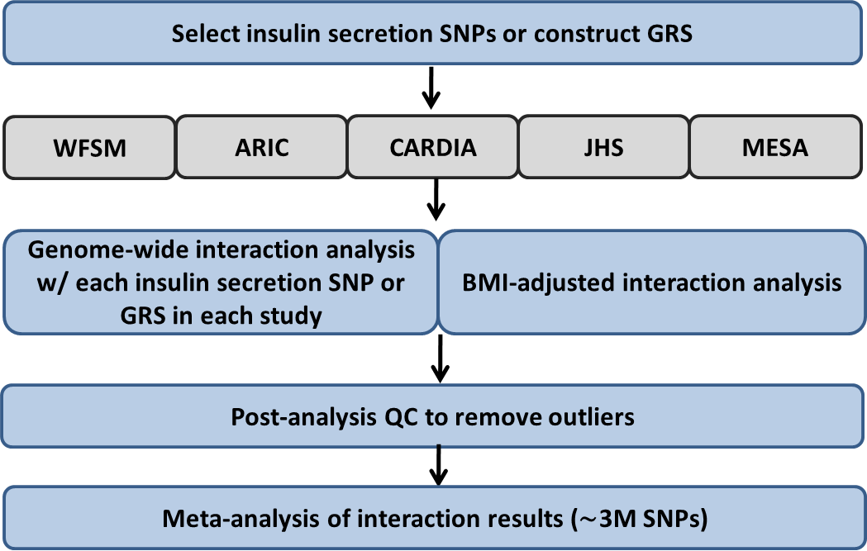

First, we selected T2D-IS SNPs or constructed the genetic risk score. Next, from our 5 study cohorts, we selected genotyped and imputed SNPs that passed our quality control thresholds. We then conducted a genome-wide interaction analysis with each T2D-IS SNP or the GRS in each study cohort separately, with or without BMI-adjustment. We conducted post-analysis QC to remove outliers from our data. Finally, we meta-analyzed our results across all study cohorts for each T2D-IS SNP or the GRS.

Supplementary Figure 4. Conservative estimates of power to detect true positive interaction effects in the ARIC, CARDIA, JHS, MESA, and WFSM cohorts at different significance thresholds.
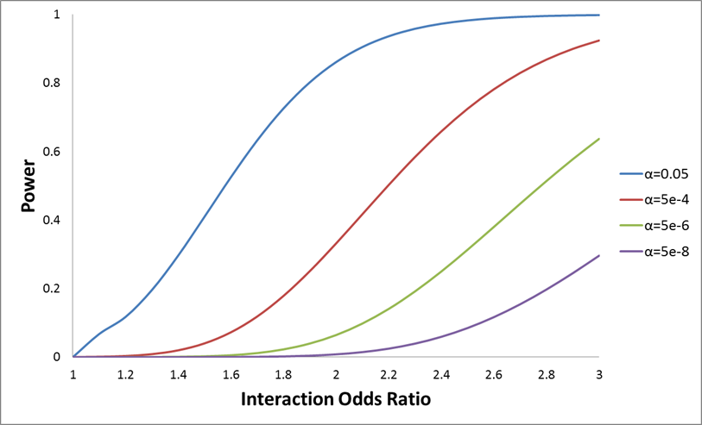
Model assumes additive effects, sample size and case/control proportions equal to the current study, minor allele frequency of 5% for both SNPs, odds ratio of 1.1 for both SNPs, and a population risk of 12.6% (consistent with population risk of T2D in African Americans). Power calculations were performed in Quanto (http://hydra.usc.edu/gxe/).

References
1. The ARIC Investigators. The Atherosclerosis Risk in Communities (ARIC) Study: design and objectives. The ARIC investigators. Am J Epidemiol. 1989 Apr;129(4):687–702.
2. Friedman GD, Cutter GR, Donahue RP, Hughes GH, Hulley SB, Jacobs DR, et al. CARDIA: study design, recruitment, and some characteristics of the examined subjects. J Clin Epidemiol. 1988;41(11):1105–16.
3. Taylor HA, Wilson JG, Jones DW, Sarpong DF, Srinivasan A, Garrison RJ, et al. Toward resolution of cardiovascular health disparities in African Americans: design and methods of the Jackson Heart Study. Ethn Dis. 2005;15(4 Suppl 6):S6–4 – 17.
4. Bild DE, Bluemke DA, Burke GL, Detrano R, Diez Roux AV, Folsom AR, et al. Multi-ethnic study of atherosclerosis: objectives and design. Am J Epidemiol. 2002 Nov 1;156(9):871–81.
5. McDonough CW, Palmer ND, Hicks PJ, Roh BH, An SS, Cooke JN, et al. A genome-wide association study for diabetic nephropathy genes in African Americans. Kidney Int. 2011 Mar;79(5):563–72.
6. Palmer ND, McDonough CW, Hicks PJ, Roh BH, Wing MR, An SS, et al. A genome-wide association search for type 2 diabetes genes in African Americans. PloS One. 2012;7(1):e29202.

